Gover2.Me API Reference

POLITICAL ANALYSIS API TECHNICAL SPECIFICATION

COMPLETE ENDPOINT DOCUMENTATION

TABLE OF CONTENTS
- General Introduction
- Radar Analysis Endpoint
- Media Affinity Endpoint
- Media Coverage Endpoint
- Technical Considerations

GENERAL INTRODUCTION

System Purpose
The Political Analysis API is a comprehensive system designed for comparative political program analysis, media landscape evaluation, and coverage tracking. It provides radar charts for multi-dimensional policy comparison, media affinity analysis, and thematic coverage visualization.

Base Architecture
- Framework: Flask
- Base URL: http://172.24.250.17:8006
- Communication: REST API
- Storage: In-memory with constant data structures
- Response Format: JSON or PNG image
- CORS Support: Enabled for all origins

Supported Topics
The API supports analysis across the following policy areas:
- vivienda (Housing)
- economia (Economy)
- sanidad (Healthcare)
- seguridad (Security)
- educacion (Education)
- transporte (Transportation)

Media Sources
The system tracks the following Andalusian media outlets:
- ABC Sevilla (https://www.abc.es/sevilla/)
- Diario SUR (https://www.diariosur.es/)
- Diario de Sevilla (https://www.diariodesevilla.es)
- El Correo de Andalucía (https://www.elcorreoweb.es/andalucia/)
- eldiario.es Andalucía (https://www.eldiario.es/andalucia/)
- IDEAL (https://www.ideal.es)
- El País (https://elpais.com/?ed=es)

RADAR ANALYSIS ENDPOINT

GET /api/radar

Executive Summary
Endpoint for generating comparative radar charts analyzing political programs across multiple dimensions. Compares positions of different political parties (PP, VOX, PSOE) against a reference program across topic-specific evaluation axes. Returns data for all parties by default.

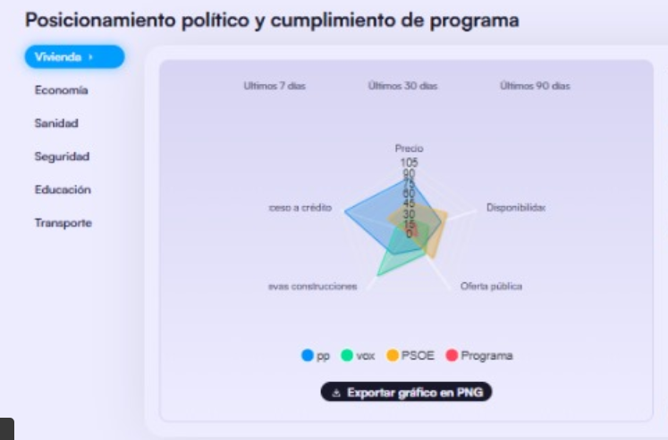

Request Structure
Query Parameters:
- topic (optional): Policy area to analyze
- window (optional): Time window for analysis
- format (optional): Response format (json or png)

Response Structure (JSON)
{
"meta": {
"topic": "string",
"window": "string",
"generated_at": "string",
"units": "string"
},
"axes": ["string"],
"series": [
{
"name": "string",
"values": [number]
}
],
"range": {
"min": number,
"max": number
}
}

Detailed Field Specification
QUERY PARAMETERS:
topic
- Purpose: Policy area for comparative analysis
- Type: String
- Required: No (default: "vivienda")
- Valid values: "vivienda", "economia", "sanidad", "seguridad", "educacion", "transporte"
- Use cases: Selection of policy domain for analysis
- Technical considerations: Determines evaluation axes and scoring dimensions
window
- Purpose: Temporal scope for data analysis
- Type: String
- Required: No (default: "7d")
- Valid values: "7d", "30d", "90d", or ISO8601 format
- Use cases: Historical trend analysis
- Technical considerations: Supports day-based shortcuts or full ISO dates
format
- Purpose: Output format selection
- Type: String
- Required: No (default: "json")
- Valid values: "json", "png"
- Use cases: API integration (json) or direct visualization (png)
- Technical considerations: PNG returns binary image data
RESPONSE FIELDS (JSON):
meta.topic
- Purpose: Confirms analyzed policy area
- Type: String
- Required: Yes
- Use cases: Response validation and context
- Technical considerations: Echo of request parameter
meta.window
- Purpose: Confirms temporal scope
- Type: String
- Required: Yes
- Use cases: Temporal context for interpretation
- Technical considerations: Echo of request parameter
meta.generated_at
- Purpose: Response generation timestamp
- Type: String (ISO 8601 format)
- Required: Yes
- Use cases: Caching and freshness validation
- Technical considerations: UTC timezone with seconds precision
meta.units
- Purpose: Measurement scale description
- Type: String
- Required: Yes
- Values: "index_0_100"
- Use cases: Scale interpretation for values
- Technical considerations: All scores normalized 0-100
axes
- Purpose: Evaluation dimensions for selected topic
- Type: Array[String]
- Required: Yes
- Use cases: Radar chart axis labels
- Technical considerations: Topic-specific dimensions (5 axes per topic)
- Examples:
  - Housing: ["Precio", "Disponibilidad", "Oferta pública", "Nuevas construcciones", "Costo a crédito"]
  - Economy: ["Inflación", "Empleo", "Crecimiento del PIB", "Salario real", "Inversión"]
series[].name
- Purpose: Political party or program identifier
- Type: String
- Required: Yes
- Values: "pp", "vox", "psoe", "programa"
- Use cases: Legend identification in visualizations
- Technical considerations: All four parties returned by default
series[].values
- Purpose: Performance scores across all axes
- Type: Array[Number]
- Required: Yes
- Range: 0.0 - 100.0
- Use cases: Radar chart data points
- Technical considerations: Array length matches axes count
range.min
- Purpose: Minimum value in scoring scale
- Type: Number
- Required: Yes
- Values: 0
- Use cases: Scale baseline for visualization
- Technical considerations: Fixed at 0
range.max
- Purpose: Maximum value in scoring scale
- Type: Number
- Required: Yes
- Values: 100
- Use cases: Scale ceiling for visualization
- Technical considerations: Fixed at 100

Response Structure (PNG)
Content-Type: image/png Format: Polar radar chart with:
- Circular grid layout
- Color-coded party lines (PP: blue, VOX: green, PSOE: orange, Programa: black)
- Dashed line for reference program
- Transparent fill for parties
- Legend at bottom center

MEDIA AFFINITY ENDPOINT

GET /api/media-affinity

Executive Summary
Endpoint for analyzing media outlet positioning relative to political messaging. Provides scatter plot data showing each outlet's argumentative alignment (affinity) versus their audience reach, enabling strategic media engagement planning.

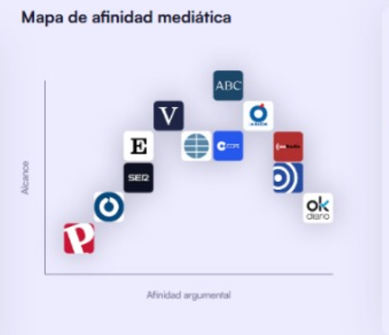

Request Structure
Query Parameters:
- window (optional): Time window for analysis
- format (optional): Response format (json or png)

Response Structure (JSON)
{
"meta": {
"window": "string",
"generated_at": "string",
"units": {
"affinity": "string",
"reach": "string"
}
},
"sources": [
["string", "string"]
],
"points": [
{
"name": "string",
"url": "string",
"affinity": number,
"reach": number
}
],
"range": {
"affinity": [number, number],
"reach": [number, number]
}
}

Detailed Field Specification
QUERY PARAMETERS:
window
- Purpose: Analysis period
- Type: String
- Required: No (default: "30d")
- Valid values: Day-based ("7d", "30d", "90d")
- Use cases: Temporal trend identification
- Technical considerations: Longer windows smooth short-term fluctuations
format
- Purpose: Output format
- Type: String
- Required: No (default: "json")
- Valid values: "json", "png"
- Use cases: Programmatic access or direct visualization
- Technical considerations: PNG generates publication-ready scatter plot
RESPONSE FIELDS:
sources
- Purpose: Complete list of tracked media outlets
- Type: Array[Tuple[String, String]]
- Required: Yes
- Structure: [["name", "url"], ...]
- Use cases: Full media landscape reference
- Technical considerations: Tuple format: (display_name, source_url)
points[].name
- Purpose: Media outlet display name
- Type: String
- Required: Yes
- Use cases: Scatter plot labeling and identification
- Technical considerations: Human-readable name derived from URL
points[].url
- Purpose: Media outlet website URL
- Type: String (URL)
- Required: Yes
- Use cases: Direct source linking and verification
- Technical considerations: Full URL for external reference
points[].affinity
- Purpose: Argumentative alignment score
- Type: Number (decimal)
- Required: Yes
- Range: 0.0 - 100.0
- Use cases: X-axis positioning in scatter plot
- Technical considerations: Higher values indicate stronger message alignment
- Interpretation:
  - 0-33: Low affinity (opposing/critical)
  - 34-66: Moderate affinity (neutral/mixed)
  - 67-100: High affinity (supportive/aligned)
points[].reach
- Purpose: Audience reach/influence score
- Type: Number (decimal)
- Required: Yes
- Range: 0.0 - 100.0
- Use cases: Y-axis positioning in scatter plot
- Technical considerations: Combines circulation, web traffic, and engagement metrics
- Interpretation:
  - 0-33: Low reach (niche/regional)
  - 34-66: Medium reach (significant regional)
  - 67-100: High reach (major/national presence)
Strategic Quadrants:
- High Affinity, High Reach (top-right): Priority partners for message amplification
- High Affinity, Low Reach (bottom-right): Relationship development opportunities
- Low Affinity, High Reach (top-left): Critical monitoring and engagement targets
- Low Affinity, Low Reach (bottom-left): Lower priority for immediate strategy

Response Structure (PNG)
Content-Type: image/png Format: Scatter plot with:
- X-axis: Affinity (0-100)
- Y-axis: Reach (0-100)
- Point labels with media names
- Grid overlay for easier reading
- Figure size: 5.5" x 4.0" at 180 DPI
- Filename format: media_affinity_{window}.png

MEDIA COVERAGE ENDPOINT

GET /api/media-coverage

Executive Summary
Endpoint for analyzing media coverage sentiment across policy topics. Provides aggregated mention counts categorized by sentiment (positive, neutral, negative) enabling identification of media narrative trends and communication gaps.

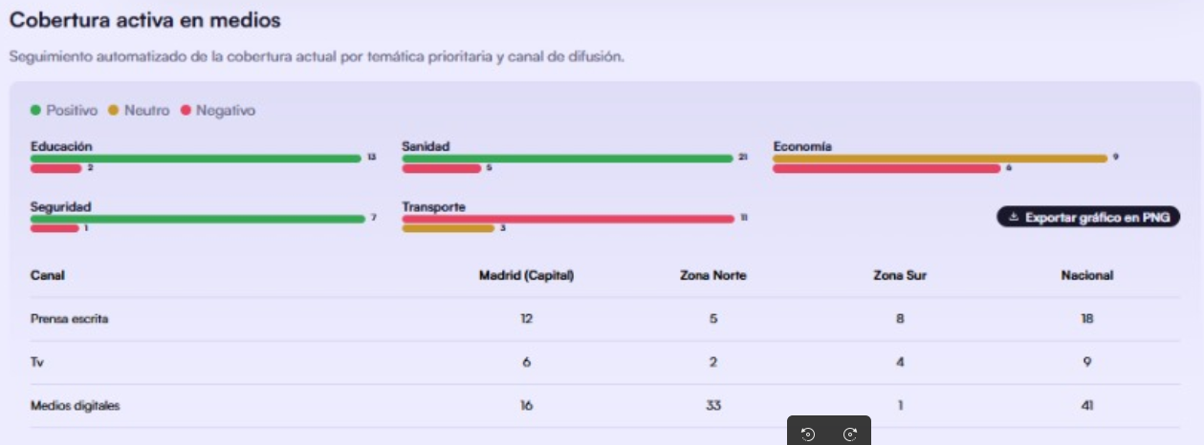

Request Structure
Query Parameters:
- topics (optional): Comma-separated list of topics to analyze
- sort (optional): Sorting criterion for results
- format (optional): Response format (json or png)

Response Structure (JSON)
{
"meta": {
"generated_at": "string",
"order": ["string"]
},
"topics": [
{
"key": "string",
"label": "string",
"counts": {
"positive": number,
"neutral": number,
"negative": number
},
"total": number
}
]
}

Detailed Field Specification
QUERY PARAMETERS:
topics
- Purpose: Selection of policy areas to include
- Type: String (comma-separated)
- Required: No (default: all topics)
- Valid values: "educacion", "sanidad", "economia", "seguridad", "transporte"
- Use cases: Focused analysis on specific policy domains
- Technical considerations: Filters output to selected topics only
sort
- Purpose: Result ordering criterion
- Type: String
- Required: No (default: "name")
- Valid values: "name", "total", "positive", "negative"
- Use cases: Priority-based result presentation
- Technical considerations:
  - "name": Alphabetical by topic label
  - "total": Descending by total mentions
  - "positive"/"negative": Descending by sentiment count
format
- Purpose: Output format selection
- Type: String
- Required: No (default: "json")
- Valid values: "json", "png"
- Use cases: Data integration or visual reporting
- Technical considerations: PNG creates horizontal stacked bar chart
RESPONSE FIELDS:
meta.order
- Purpose: Sentiment category sequence
- Type: Array[String]
- Required: Yes
- Values: ["positive", "neutral", "negative"]
- Use cases: Consistent data interpretation across clients
- Technical considerations: Defines stacking order in visualizations
topics[].key
- Purpose: Programmatic topic identifier
- Type: String
- Required: Yes
- Values: "educacion", "sanidad", "economia", "seguridad", "transporte"
- Use cases: Data processing and filtering
- Technical considerations: Machine-readable key
topics[].label
- Purpose: Human-readable topic name
- Type: String
- Required: Yes
- Values: "Educación", "Sanidad", "Economía", "Seguridad", "Transporte"
- Use cases: Display labels in UI
- Technical considerations: Properly capitalized Spanish names
topics[].counts.positive
- Purpose: Number of positive sentiment mentions
- Type: Number (integer)
- Required: Yes
- Range: ≥ 0
- Use cases: Supportive coverage tracking
- Technical considerations: Mentions favorable to government position
topics[].counts.neutral
- Purpose: Number of neutral sentiment mentions
- Type: Number (integer)
- Required: Yes
- Range: ≥ 0
- Use cases: Balanced reporting identification
- Technical considerations: Factual mentions without clear sentiment
topics[].counts.negative
- Purpose: Number of negative sentiment mentions
- Type: Number (integer)
- Required: Yes
- Range: ≥ 0
- Use cases: Critical coverage monitoring
- Technical considerations: Mentions unfavorable to government position
topics[].total
- Purpose: Sum of all mentions across sentiments
- Type: Number (integer)
- Required: Yes
- Range: ≥ 0
- Use cases: Overall coverage volume assessment
- Technical considerations: positive + neutral + negative = total
Coverage Interpretation Guidelines:
- High positive ratio: Strong narrative control
- High negative ratio: Communication challenges, crisis potential
- High neutral ratio: Factual dominance, opportunity for message shaping
- Low total: Under-covered topic, communication gap

Response Structure (PNG)
Content-Type: image/png Format: Horizontal stacked bar chart with:
- Green bars: Positive mentions (with count labels)
- Yellow bars: Neutral mentions (with count labels)
- Red bars: Negative mentions (with count labels)
- Legend at bottom right
- Dynamic height based on topic count
- Figure size: 7.5" x (2.6 + 0.35 × topic_count) at 180 DPI

TECHNICAL CONSIDERATIONS

Data Persistence
Current Implementation: In-memory constant data structures
- Media affinity scores stored in MEDIA_AFFINITY_CONST
- Coverage counts stored in CONSTANT_COVERAGE
- Radar scores in get_scores() function
Implications:
- Consistent results across requests
- No database required for deployment
- Suitable for demonstration and testing
- Production systems should integrate with live data sources

Visualization Specifications
Matplotlib Configuration:
- DPI: 180 (high-resolution output)
- Backend: Agg (non-interactive, server-optimized)
- Output: PNG format with BytesIO buffer
Chart Styling:
- Grid: Alpha 0.3-0.5, linewidth 0.4-0.6
- Colors: Semantic (green=positive, yellow=neutral, red=negative)
- Text: Sizes 7-8pt for labels, proper contrast for readability

Performance
Response Times (typical):
- JSON endpoints: < 50ms
- PNG generation: 200-500ms (matplotlib rendering)
Optimization Recommendations:
- Implement caching for generated images
- Consider SVG format for smaller file sizes
- Pre-generate common visualizations

Error Handling
Current Behavior:
- Invalid topic: Falls back to default
- Missing parameters: Uses defaults
- Invalid format: Returns JSON
Best Practices:
- Validate all query parameters
- Return 400 for invalid inputs
- Provide descriptive error messages

CORS Configuration
Current: Enabled for all origins (*)
Production Recommendations:
- Restrict to specific domains
- Implement authentication
- Use HTTPS only

API Versioning
Current: Implicit v1 in URL paths
Future Considerations:
- Maintain backward compatibility
- Document deprecation timelines
- Support multiple versions simultaneously

Rate Limiting
Current: Not implemented
Recommendations:
- Implement per-IP limits
- Higher limits for authenticated clients
- Separate limits for PNG generation (resource-intensive)

Monitoring
Health Endpoint: Not currently implemented
Suggested Addition:
GET /health
Response: {"status": "ok", "version": "1.0", "uptime_seconds": 12345}

Scalability Considerations
Single Server Limitations:
- In-memory data limits concurrent users
- Matplotlib rendering is CPU-intensive
Scaling Strategies:
- Horizontal scaling with load balancer
- Separate image generation service
- CDN for generated visualizations
- Redis for shared caching layer

APPENDIX: TOPIC-SPECIFIC AXES

Housing (vivienda)
- Precio (Price)
- Disponibilidad (Availability)
- Oferta pública (Public offering)
- Nuevas construcciones (New constructions)
- Costo a crédito (Credit cost)

Economy (economia)
- Inflación (Inflation)
- Empleo (Employment)
- Crecimiento del PIB (GDP Growth)
- Salario real (Real wages)
- Inversión (Investment)

Healthcare (sanidad)
- Listas de espera (Waiting lists)
- Atención primaria (Primary care)
- Cobertura (Coverage)
- Personal sanitario (Healthcare personnel)
- Infraestructura hospitalaria (Hospital infrastructure)

Security (seguridad)
- Delitos (Crimes)
- Respuesta policial (Police response)
- Percepción de seguridad (Security perception)
- Recursos y equipamiento (Resources and equipment)
- Eficacia judicial (Judicial effectiveness)

Education (educacion)
- Resultados académicos (Academic results)
- Infraestructura (Infrastructure)
- Docentes (Teachers)
- Acceso y becas (Access and scholarships)
- Digitalización (Digitalization)

Transportation (transporte)
- Oferta y frecuencia (Service and frequency)
- Infraestructura vial (Road infrastructure)
- Puntualidad y confiabilidad (Punctuality and reliability)
- Accesibilidad (Accessibility)
- Seguridad vial (Road safety)

